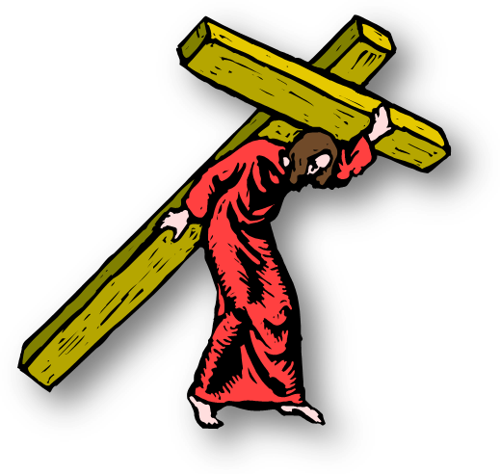
We Believe in Discipleship
Matthew 16:13-26

Introduction:

We have been insisting, and rightly so, that at salvation the unbeliever is not required to promise, do or intend to do anything in order to receive the free gift of eternal life.

This emphasis might mislead some, even us, into thinking that, if that’s the case, then discipleship is not important.

Everyone Agrees that Discipleship is Costly!

I. The Issue

If the conditions of discipleship are also conditions of salvation, then every Christian is, by definition, a disciple.

If, on the other hand, these conditions are not conditions for salvation, then the issue of discipleship must be distinguished from the issue of salvation. Then it can be shown that:


Discipleship is Truly Costly
And
Salvation is Truly Free

Our Question About Discipleship:

Is not -What will God do to me if I don’t submit?

But - What will God do for me if I do?

- The “Costly Grace” View

The concept of “costly grace” became popular as an answer to the apathy and worldliness of contemporary Christians.

Dietrich Bonhoeffer first coined the phrase, 1949. He said,

“The only man who has the right to say that he is justified by Grace alone is the man who has left all to follow Christ.”

This is like saying, The only man who can say that he has a free gift is the man who has a cancelled check.

So, “Lordship” proponents solve the problem of professors not living up to their profession by demanding that sinners pay the price for their (free) salvation, the price is submission and obedience.

J.I. Packer wrote concerning the cost of following Christ:

“We must “make sinners face it soberly before we urge them to respond to the message of free forgiveness. In common honesty, we must not conceal the fact that free forgiveness in one sense will cost everything.”

In other words, he is saying that salvation and discipleship is one and the same thing.


The “Costly but Free” contradiction is explained as a theological “paradox.

- The “Free Grace” View

Opponents of “free grace” call the position “cheap grace”

What does “Cheap” mean? - It means that it didn’t cost much.

We prefer the name “free grace” emphasizing the freeness of salvation and the simplicity of faith.

Salvation and Discipleship are Separate Issues!

Salvation concerns the sinner’s acceptance of the free of eternal life and the forgiveness of sins through faith alone.

Discipleship concerns the believer’s response to the grace received by offering himself to God in submission, obedience, and sacrifice.

In salvation, Christ paid the price; in discipleship, the believer pays the price. Christ paid the price. (So it is not cheap after all).

Therefore, Salvation is free, but Discipleship is costly.

Because they are separate issues, there is no contradiction. Therefore, no paradox!

II. The Conditions of Discipleship

- The Conditions at Peter’s Confession

1. The background

a. Jesus’ question and Peter’s confession

1) Who do men say that I am? - John B., Elijah,
Jeremiah, 1 of prophets

2) You are the Christ, the son of the living God.

Not flesh and Blood, but My Father…

b. Jesus’ prediction of His death and resurrection. Doing the Father’s will - Go to Jerusalem and suffer... Be killed, raised the third day.

c. Peter’s rebuke of Christ – 16:22-23

“Be it far from you, LORD. This shall not happen to you!”

Essentially, he is denying that God’s will requires such a price.

Jesus responds in verse 23, “Get behind me, Satan, you are an offense to Me.” You are not mindful of the things of God, but, the things of men.

2. The audience

a. He spoke only to the disciples.

Matthew mentions only the 12 disciples. The disciples (except for Judas) were believers.

b. He spoke to the disciples and the crowd listened in.

Mark and Luke add that there were the crowds as well.

On another occasion, when there was a large crowd, Luke says that He spoke to His disciples first. (12:1)

There may well have been many believers in the crowd.

These sayings apply to the issues of a deeper relationship to Him and NOT to salvation.

His message was to believers, telling them that they must follow His example in doing the Father’s will.

Nothing less than total commitment will do.

B. Specific Conditions for Discipleship

As it cost Jesus to do the Father’s will, so it will cost the disciples.

He uses the words “come after Me” ὀπίσω μου - That’s Discipleship.

Not “come to Me.” ἐρχόμενον πρὸς ἐμὲ - that’s Salvation.

1. “Deny Himself”

Notice: There is nothing here about believing, forgiveness of sins or justification of the sinner.

The example (Jesus) was about to submit Himself and His desires to the desire of the Father.

Peter’s rebuke of Jesus concerning this submission in v23 is called “being mindful of the things of man not the things of God.”

In passages which deal unquestionably with eternal salvation, no mention of self denial etc. as a requirement for salvation.

2. “Take up his Cross”

“Denying self” seems to be the decision to follow Christ and the next 2 are the actual doing of that decision.

Just as Jesus took up His cross, so we figuratively take up our cross and do the deeds that must be done to serve Him.

Not carrying a wooden cross around, but sacrificing our will to do His will.

3. “Follow Me”

This denotes a pupil/teacher relationship.

It is a continuously committed lifestyle.

Because following another person is a process, a progression, and requires time, this condition cannot speak of entrance into salvation.
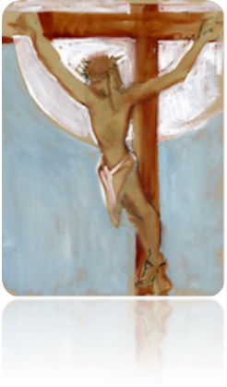
4. “Lose his Life”

This is a summary of the other three.

When we deny our own desires,
suffer in obedience and,
continuously follow Christ in the will of God,
we are losing our lives to the will of God.

It pictures Jesus’ losing His life physically.
In verses 25-26, the word “life” occurs 4 times. In some versions translated “life” twice in verse 25 - translated “soul in verse 26.

Other versions translate life all 4 times. I think they are correct.

Charlie Bing writes:

"Whoever desires to preserve himself from the hardships of God’s will of self-denial and cross-bearing will in fact forfeit the essential quality (= true spiritual value) of the present life he is trying to preserve. On the other hand, whoever forfeits himself to God’s will of self-denial and hardships will discover the greater essential quality (spiritual value) of the present life he was willing to forfeit."

This interpretation would therefore not describe eternal salvation, but

a. A higher quality of experience with God in this life, with,

b. Implications for the eschatological life, as the next section will show.

Matthew 16:27
“For ﻿﻿the Son of Man will come in the glory of His Father ﻿﻿with His angels, ﻿﻿and then He will reward each according to his works”.

ἀποδώσει recompense – means good or bad

5. “Whoever is Ashamed of Me”

Mark 8:38
“For whoever ﻿﻿is ashamed of Me and My words in this adulterous and sinful generation, of him the Son of Man also will be ashamed when He comes in the glory of His Father with the holy angels.”

Other Conditions not in this Passage

1. Hate your family
2. Forsake all
3. Abide in His Word

Conclusion from these Conditions

It means
taking up the cross daily,
giving all for Christ each day
with reservations, uncertainty, hesitation.
nothing is knowingly held back,
nothing purposely shielded from His lordship,
nothing stubbornly kept from His control.

Is that a true statement? It depends:

Are we talking about salvation?

Are we talking about discipleship?

That is the whole point of this message.

III. The Difference between Discipleship and Salvation.

Salvation | Discipleship
Justification | Sanctification
By grace | By works
Through faith  Free  Christ’s love for me  Christ’s commitment to me  Christ’s cross for me  Eternal life | Through faithfulness  Costly  My love for Christ  My commitment to Christ  My cross for Christ  Eternal rewards
An unbeliever’s response | A believer’s response
Instantaneous | Progressive
New birth | Continued growth
One condition | Many conditions
Christ as Savior |  | Christ as Lord
Will of God in Redemption Whole will of God

Response to Christ’s Death Response to Christ’s life

Can take place apart from Cannot take place apart from Justification Sanctification

